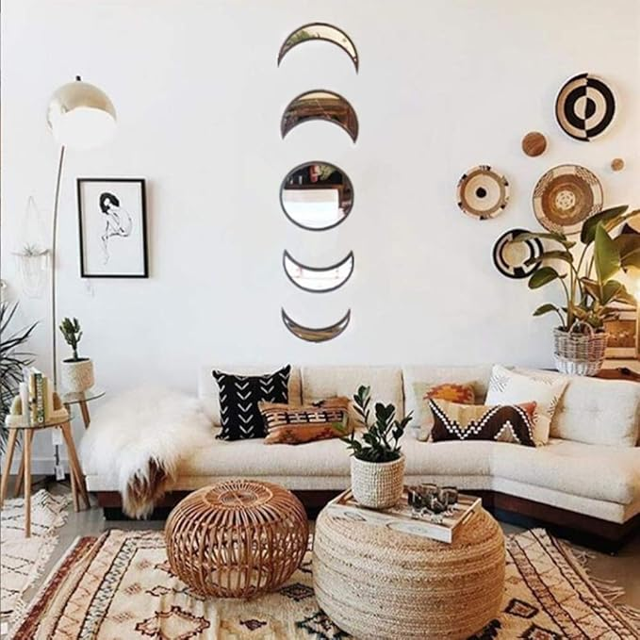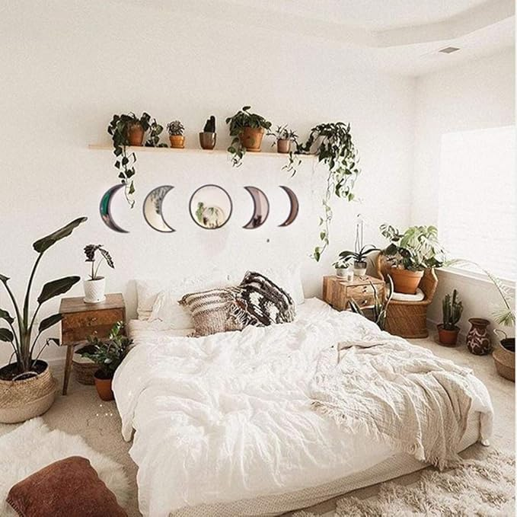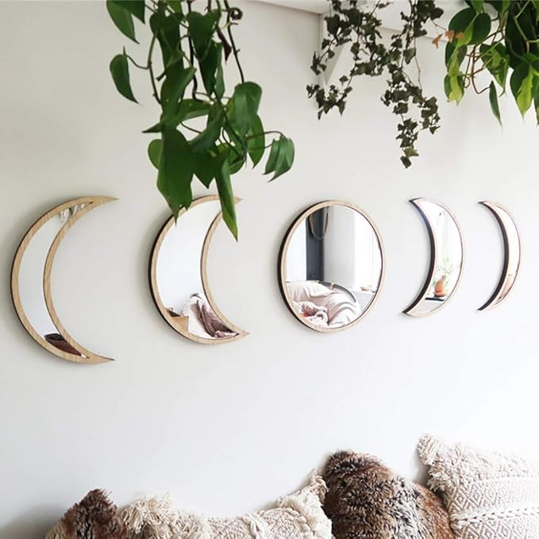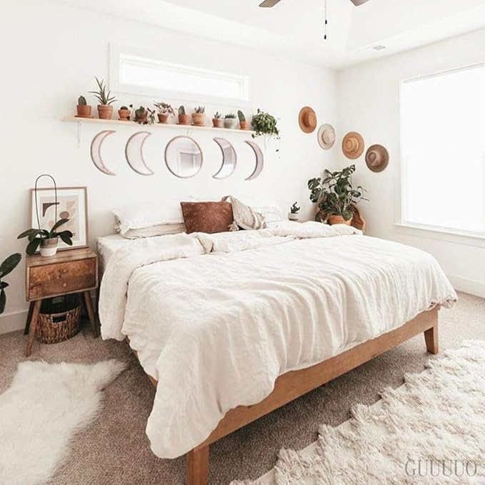

5 Pieces Scandinavian Natural Decor Acrylic Wall Decorative Mirror Interior Design Wooden Moon Phase Mirror Bohemian Wall Decoration for Home Living Room Bedroom Decor - Acrylic,Not Real Mirror(Beige)

**PRODUCT DESCRIPTION:**

|  |  |
| --- | --- |
| Brand | Keweis |
| Room Type | Living Room |
| Shape | Round |
| Product Dimensions | 10.5"L x 10.5"W |
| Frame Material | Wood |

**About this item**

* Materials: Moon Phases Mirror Sets made of imitation wood and acrylic panels, not like ordinary mirrors to fragile easily, also not have the same imaging effect of mirror, they just become decorations to increase more beauty and energy for your life. Please remove the protective film of the mirror when you fix them on the wall.
* Bright and Spacious: They can easily reflect the surrounding light and make your home feel brighter and more spacious. You can also make the satellite both outward and inward by switching the order around the crescent moon.
* Perfect Decoration: You are looking at a full set of wooden moon phase mirrors for your home! These mirrors are the perfect complement to all moon lovers' rooms and are a great spiritual home decoration!
* How To Use: Please paste on the smooth wall surface with free stickers, such as plastic surface, smooth wallpaper, smooth glass, wooden surface, ceramic tile surface, metal surface, latex paint wall surface; do not use on the powder coated wall surface.
* Free Combination: Five different moon phase shapes can be combined as needed, or they can be deleted and pasted to decorate various parts of the house. The moon-shaped acrylic plate mirror stickers are made of non-toxic and harmless materials, so you don’t have to worry about the smell.